5th March 2019

**YOKOHAMA to Launch European Sales of “GEOLANDAR X-CV”, Highway Terrain Tyre for High-Performance Crossover SUVs**

YOKOHAMA announced today that it will begin European sales of the “GEOLANDAR X-CV*”, a highway terrain tyre in its GEOLANDAR brand for SUVs, from this spring. The tyre will be available in 23 sizes, ranging from 275/40R22 108W to 255/55R18 109W.   
*The “CV” in GEOLANDAR X-CV is short for crossover vehicles.  
  
The “GEOLANDAR X-CV” is a new highway terrain tyre developed specifically for the increasingly popular midsize and large monocoque-structure high-performance crossover SUVs that emphasize high-speed performance and drivability. While delivering the safety, comfort, durability and fuel efficiency ideal for these SUVs, the “GEOLANDAR X-CV” also has the M+S designation. In addition, all tyre sizes have the “W” speed rating that indicates they are approved for speeds up to 270km/h.   
  
The tyre’s specially developed asymmetric tread pattern features four wide straight grooves and 2-3D combination sipes. This pattern and a tread compound that is based on a high-silica compound combine to deliver safety and durability through superior wet-braking performance and abrasion resistance as well as greater fuel efficiency. In addition to the asymmetric tread pattern, the tyre’s unique structure that combines high rigidity with high durability increases stability when running at high speeds, making for a comfortable ride while driving vigorously on long highway road trips. The tread block’s five pitch variation suppresses annoying pattern noise, contributing to a quieter ride. The new “GEOLANDAR X-CV” surpasses the performance of YOKOHAMA’s “PARADA Spec-X (PA02)” in many areas, including an 8% improvement in wet braking, 3% advantage in wet handling stability, 23% less road noise and 2% less pattern noise (comparisons of noise energy reduction rates), and 3% reduction in rolling resistance.   
  
GEOLANDAR is YOKOHAMA’s global brand for SUVs and pickup trucks. YOKOHAMA is accelerating its introduction of new additions to the brand to meet diversifying needs in the SUV market in recent years. In addition to the “GEOLANDAR X-CV” and the recently introduced “GEOLANDAR X-MT”, a mud-terrain tyre with a high hobby orientation, the GEOLANDAR brand includes the mud-terrain tyre “GEOLANDAR M/T G003”, the all-terrain “GEOLANDAR A/T G015”, the “GEOLANDAR H/T G056” highway tyre for midsize and large SUVs, and the “GEOLANDAR SUV” for urban crossovers and small/midsize SUVs.

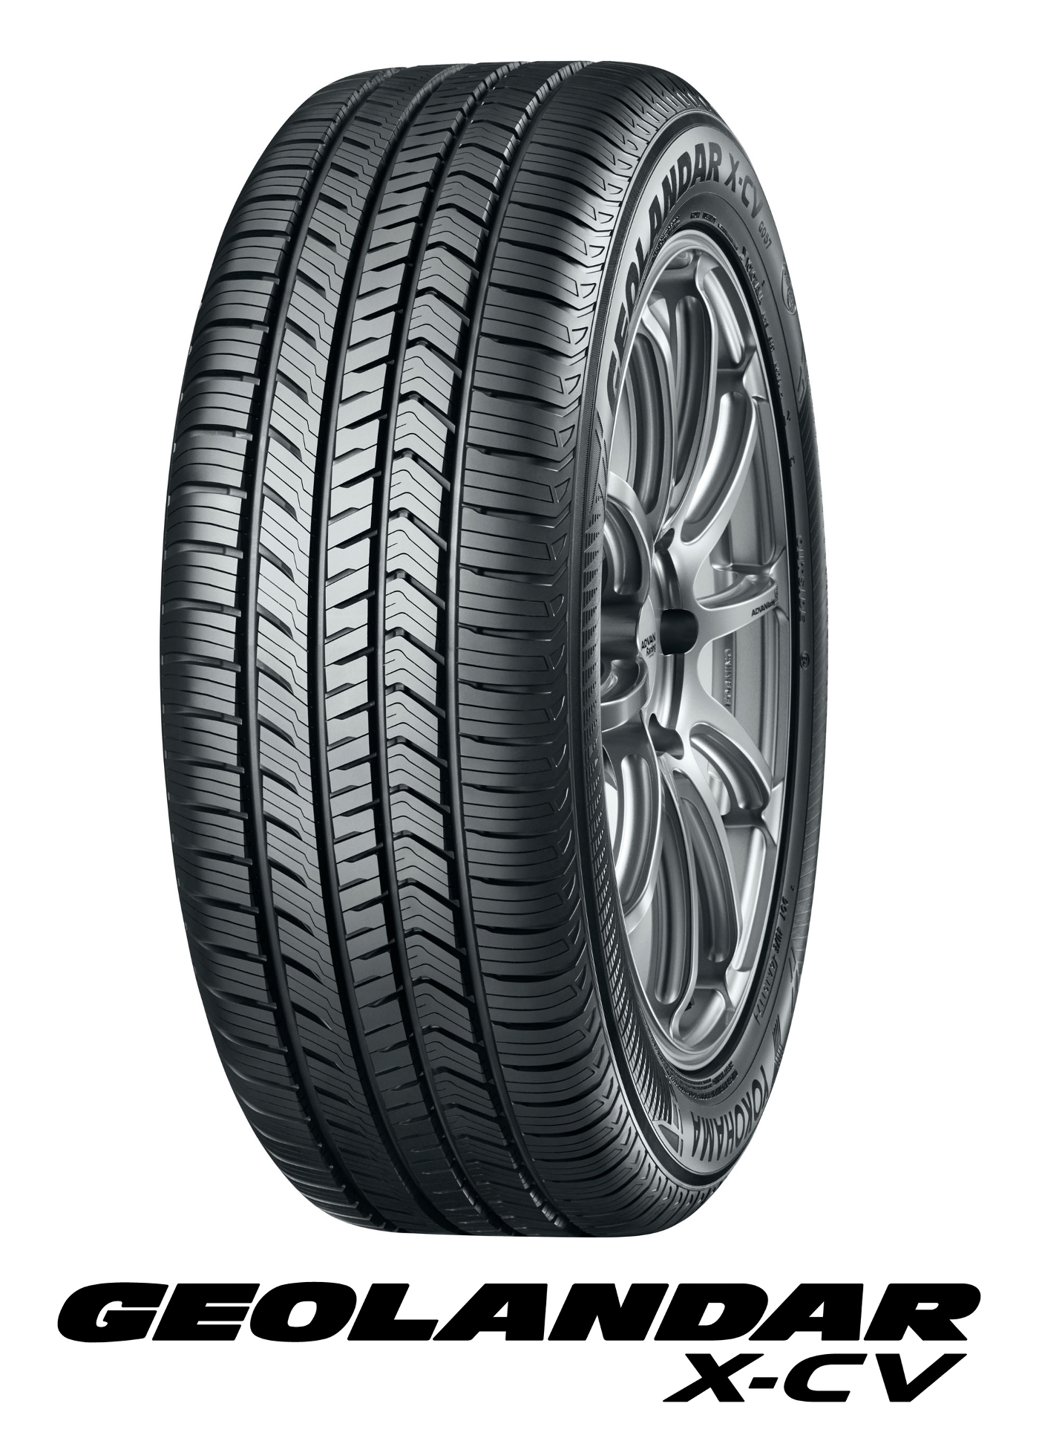

*GEOLANDAR X-CV*

*Asymmetric tread pattern enhances stability at high speeds and wet performance*

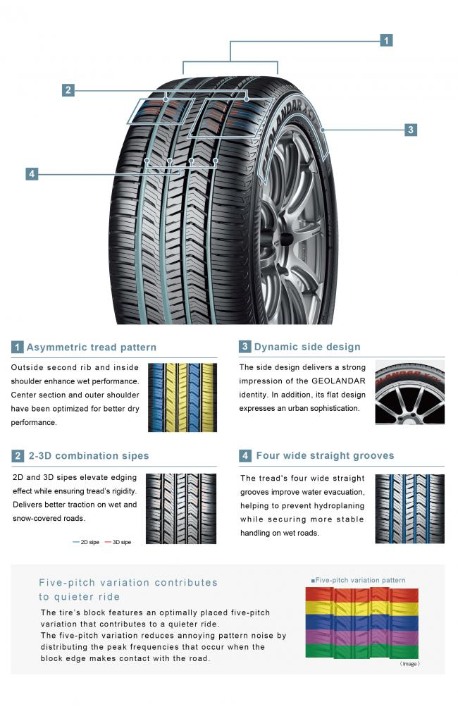

##### *High-silica & high-performance compound enhances wet performance and abrasion resistance*

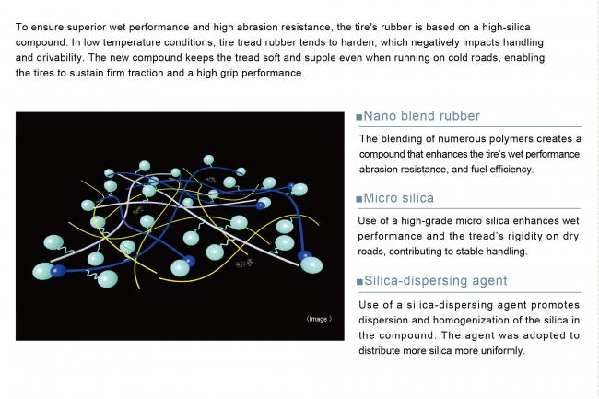

##### *Unique highly rigid structure transmits stable feeling when driving at high speeds*

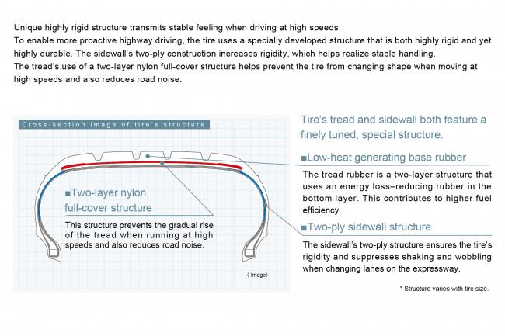

##### *Unique profile design enhances tire’s safety and enhances resistance to uneven wear resistance*

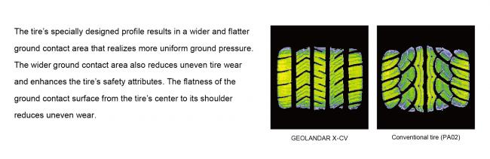

##### *Available Sizes*

